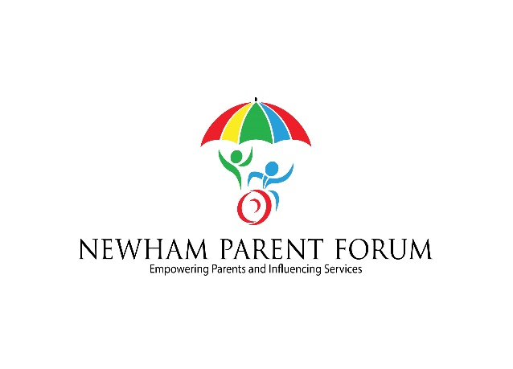  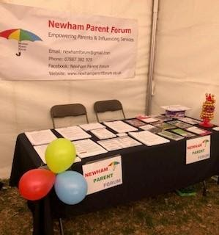  TUESDAY 10th March 2020  newham parent forum  Coffee Morning  10am-12pm  St Marks Community Centre,  218 Tollgate Road, E6 5YA  Guest Speaker: Julie Mellor  ‘Reviewing the mapping of the Autism pathway’  ALSO  - Did you have your say on the SEND Funding consultation?  - OFSTED Inspection yet to come  - Be informed and have your say about the £8.5m over spend.  - No need to book - Just pop along – All welcome  Looking forward to seeing you there.  No free parking available, 262 & 300 bus route plus Beckton dlr | DATES FOR DIARY  Next coffee morning:  Future Coffee mornings will be 2nd Tues of every month aside from holiday times.  ————————————  Newham Parent Forum would like to know what areas our families would like us to cover over the next 6 months  ————————————  http://www.newhamparentforum.co.uk  ————————————  Keep a look out for our wellbeing events  newham parent forum  St Marks Community Centre,  Room 12,  218 Tollgate Road,  Beckton  E6 5YA  Email:  newhamforum@gmail.com  Facebook: Newham Parent Forum  Twitter: @NPF_SEND

